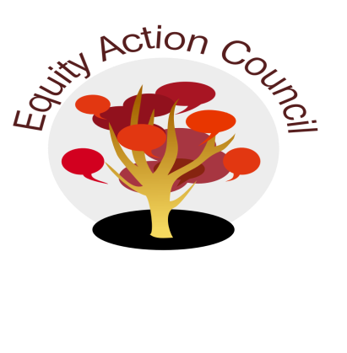
Time | Topic | Process | Facilitator(s)
1:30 pm | Introduction | Conocimiento and Check In | Alicia Cortez
1:50 pm |  | Community Updates  - Scenarios | Edmundo Norte + Alicia Cortez
 |  | - Academic Senate and EAC Collaboration  - Chancellors Equity to Excellence Mini-Grants | Alicia Cortez +  Karen Chow
2:45pm | Updates | - UndocuAlly  - Equity and Engagement Division:  Student Employee Equity Training  - DASB Updates | Angelica Esquivel Moreno  Tony Santa Ana  Rex Zhang
2:45pm | Closure | - Announcements and Events  - Appreciations | All

EAC Community Agreements
Show up, and choose to be present
Pay attention to what has heart and meaning
Tell the truth without blame or judgment
Be open to outcome, not attached to outcome
From The Four-Fold Way® by Angeles Arrien, Ph.D.

